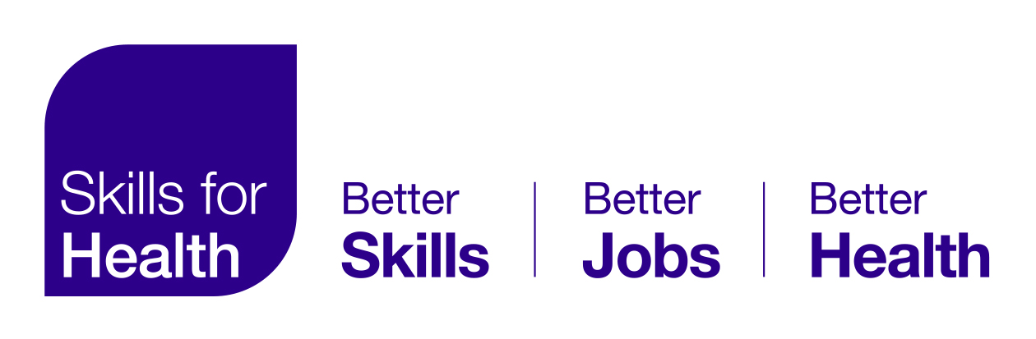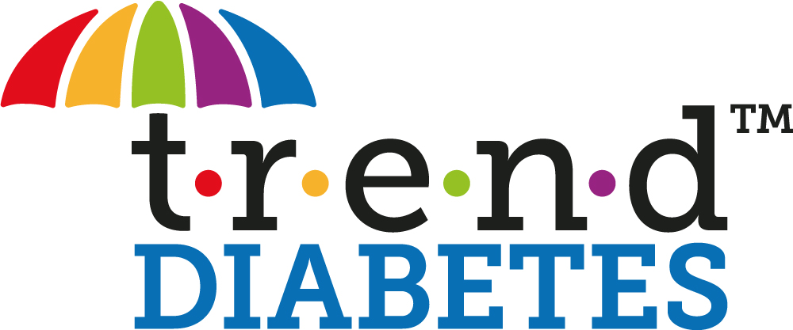

PRESS RELEASE
Embargoed until 9am on Thursday, March 25, 2021

Partnership to increase access to insulin safety module

The UK’s leading not-for-profit online learning provider for health and social care settings has added a “gold standard” insulin safety course to its portfolio to increase access outside of the NHS.

Skills for Health now hosts the Trend Diabetes ‘Insulin Safety: Getting it Right’ e-learning module.

According to the results from the latest National Diabetes Inpatient Audit¹, two in five people with diabetes on insulin (40 per cent) experience an error related to the administration of the drug while in hospital. Errors have also been reported in the community, with 8,226 errors occurring in the community from January 2013 to the end of 2015².

In response, Trend Diabetes launched the ‘Insulin Safety: Getting it Right’ e-learning module last October and made it available to all NHS trusts free of charge with the aim of reducing insulin errors by providing free education to healthcare professionals.

Under the new partnership, the module will still be free for NHS Trust Employers, but the greater reach of Skills for Health means it will now also be accessible to professionals working in social care and organisations including nursing and care homes, prisons and private hospitals.

Skills for Health is the UK’s leading not-for-profit online learning provider for health and social care settings, working closely with NHS professionals to ensure online training meets current topics, trends and policies.

Trend Diabetes is an organisation with more than 14,000 members that represents all diabetes nursing groups and is led by Co-Chairs Debbie Hicks and June James, who are both highly experienced Diabetes Nurse Consultants working in the NHS.

June authored the original NHS Diabetes insulin safety e-learning module launched in 2010, which saw more than 200,000 people take part.

She said: “As an organisation dedicated to diabetes nursing, we are passionate about high-quality care and reducing insulin errors. This e-learning module has been hugely popular in the NHS since launching, it will be further accessible to professionals outside of the NHS.”

Debbie added: “Insulin is a life-saving drug but can be lethal if not used correctly and safely. Insulin needs to be respected, unfortunately insulin errors still happen. Healthcare professionals need to be fully educated about insulin safety to help eradicate unnecessary errors.”

Chris Williams, Client Director – Learning Solutions at Skills for Health, described the module as the “gold standard for insulin safety courses available in the UK”.

Chief Technical Officer of Skills for Health Paul Walker said: “With diabetes prevalence rising globally and in the UK, Skills for Health is committed to create a greater awareness of this condition, whilst also looking to do all it can to mitigate any risks with insulin use. We are therefore very pleased to be aligning our learning with Trend Diabetes, an organisation that has a wealth of knowledge and experience in this area.”

Original authors of the Core Skills Training Framework (CSTF), Skills for Health provides statutory and mandatory guidelines for online learning which effectively align national legislation with the needs of the healthcare workforce. It is also the Sector Skills Council for the health economy, bringing a wealth of knowledge and expertise to the development of a compliant workforce.

The Skills for Health eLearning Platform offers unparalleled learning experience delivered on a secure mobile-first solution. As well as the newly added ‘Insulin Safety: Getting it Right’ course, this platform offers a wide range of additional courses (i.e. a complete suite of Safeguarding training, Infection Prevention & Control, Resuscitation and many more) designed to support the ongoing development of the healthcare workforce. This simple and easy to access tool offers learning managers a great way to track performance and ensure compliance while developing the skills of their staff.

Insulin is a high-risk medication in the UK and worldwide. The development of over 30 different insulin products and a variety of devices has led to confusion among both people living with diabetes and healthcare professionals.

NHS Improvement identifies moderate to severe harm or death caused by insulin error. In the last decade attempts have been made to upskill people with diabetes and healthcare professionals (NHS Digital 2018) with varying levels of success.

This Trend Diabetes e-learning module will provide NHS trusts with a free and viable way of incorporating insulin safety training into their electronic learning management systems.

To access the e-learning module, click here.

eLearning course for hospitals and community trusts

Notes to editors

- For further details, to arrange an interview or more photographs, email or kristy.hobbs@ojpr.co.uk
- Alternatively call 01604 882342.
- Trend Diabetes is a working group of nurses with a wide range of different skills and backgrounds in diabetes care. It was set up in 2009 in response to a request by the National Clinical Director for Diabetes at the time, who wanted a collective voice representing all diabetes nursing groups.
- Co-Chairs Debbie Hicks and June James lead the Trend Diabetes committee, with members representing different fields of nursing offering a variety of knowledge and expertise, all ensuring a true representation of diabetes nursing is achieved.
- The committee is keen to include representation from nurses from a variety of diabetes working environments, and from the four countries of the UK, to be a voice for all nurses working in diabetes, as well as a resource for those nurses.
- For more information about Trend Diabetes, visit https://trend-uk.org.
- Skills for Health is a not-for-profit organisation committed to the development of an improved and sustainable healthcare workforce across the UK. Established in 2002 as the Sector Skills Council for the UK health sector, it helps organisations deliver outstanding services through better workforce planning, design, and development so that staff have the skills and understanding needed to develop their expertise, improve their performance, and operate effectively in the workplace.

References

^{1.}NHS Digital, National Diabetes Inpatient Audit England and Wales, 2017: Page 77. 2018. Web. 16 March. 2018.
^{2.} Journal of Diabetes Nursing, James J and Diggle J. (Insulin error: Is there a new kid on the

block? Volume 20 No 6 2016. Web. 24 March. 2021.

