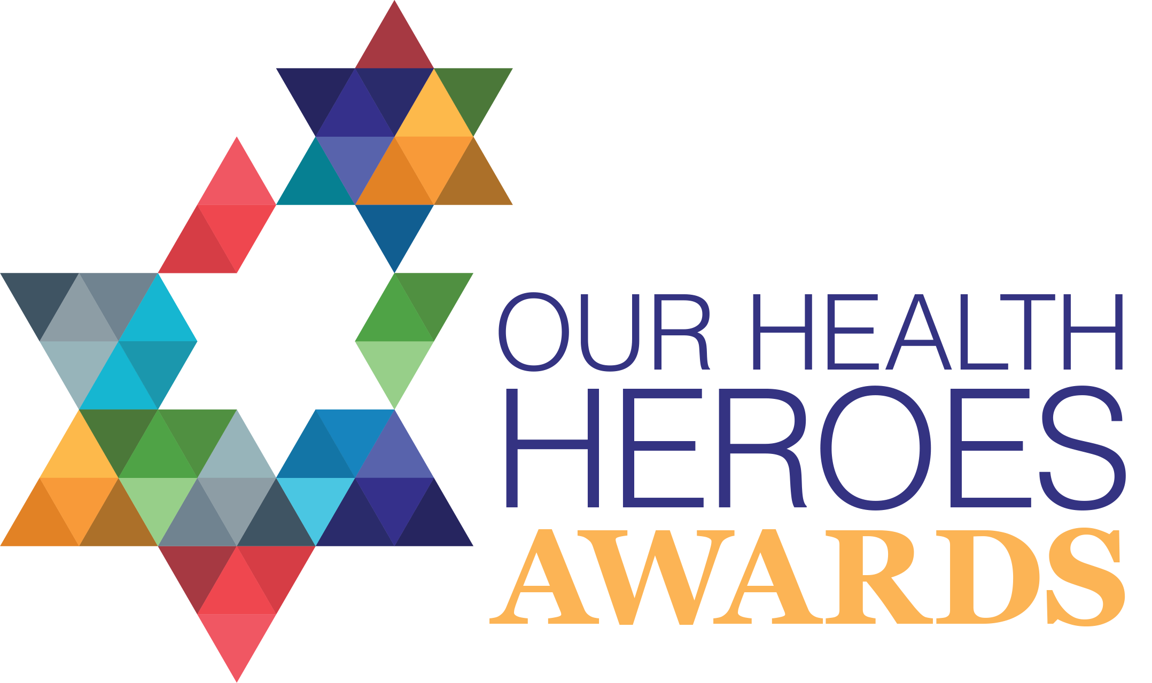

Overview
The Our Health Heroes Awards are a national awards scheme dedicated to recognising the commitment and hard work of health and care staff, particularly those in support roles. Over 40% of the NHS is made up of people with unique experiences in thousands of unique roles. These people are Our Health Heroes, and often think they are just “doing their job”. Without these people the UK’s healthcare system simply wouldn’t survive.

Our goal is to shine a light on those going above and beyond to support patients and service users. We aim to raise their profile and ensure that our support for the entire workforce is unwavering. Delivered by Skills for Health with support from headline sponsors Health Education England, and award category sponsors UNISON and NHS Employers, the Our Health Heroes Awards ceremony will be held with a hybrid event at London’s Science Museum in March 2022.

How to nominate
Please read the award criteria for each category carefully by clicking on the available links on www.skillsforhealth.org.uk/ohh or download our helpful hints to complete your nomination.

Once you have completed the nomination form, email it to ohhawards@skillsforhealth.org.uk no later than 5pm on Thursday 14th October. Please wait up to 2 working days to receive confirmation that your nomination has been successfully submitted.

Award Category

Most Promising OD & People Programme

If you’d like to nominate for any of the other 10 categories, please click here.

About you – the nominator
Full Name
Email Address
Organisation | If not applicable leave blank
Job Title
Comms Team
(Please provide an email address for your communications or marketing team.)

About the person / team being nominated

Full Name
(Main contact if nominating for a team award)
Email Address
Job Title
Organisation
Phone Number
Manager
(If you are not the nominee’s manager.)
UNISON branch | If not applicable leave blank

Your nomination – about the person / team being nominated
Tell us about your nominee in no more than 500 words to nominate.
Type your nomination here…

